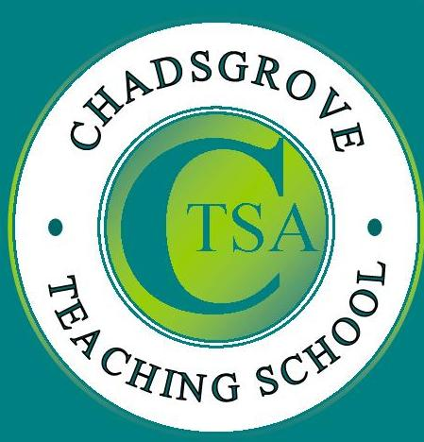
Chadsgrove
Teaching School Alliance
Conference on Special Educational Needs

ADHD, Autism, SLI and SpLD
~ What do they all have in common?
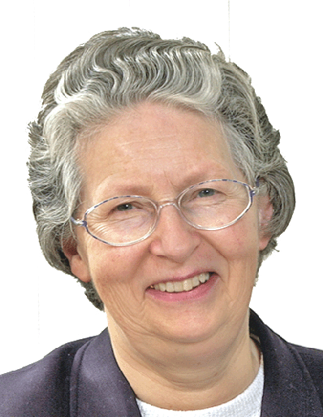

March 16th 2015
Bromsgrove, Worcestershire

Dr Rona Tutt OBE
Rona is a past president of NAHT and represents the association on a number of committees, including the Special Education Consortium (SEC), the National SEND Forum (NSENDF), the Autism Education Trust (AET), the Food for the Brain Foundation (FfB) and the National Literacy Association (NLA). In 2004 Rona received an OBE for her services to special needs education.

Chadsgrove Teaching School is delighted to invite you to attend this groundbreaking conference. Eminent national and international speakers will explore the issues relating to this rapidly growing population of children with co-existing and overlapping special educational needs.
Conference fee £145

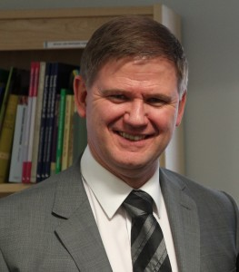
Prof Barry Carpenter OBE
Barry is honorary professor at the universities of Worcester, Limerick, Hamburg and Flinders. In a career spanning over 30 years, Barry has held the leadership positions of academic director, chief executive, principal, headteacher, inspector of schools and director of the centre for special education at Westminster College, Oxford. In 2001 Barry was awarded an OBE for services to children with special needs.

Our speakers will explore current understanding of the similarities and differences between a group of developmental disorders: Attention Deficit Hyperactivity Disorder, Autism, Specific Language Impairment, Specific Learning Disabilities.
Presentations, panel discussions and workshops will enable delegates to consider current perspectives, future trends, and the implications for provision and resources.

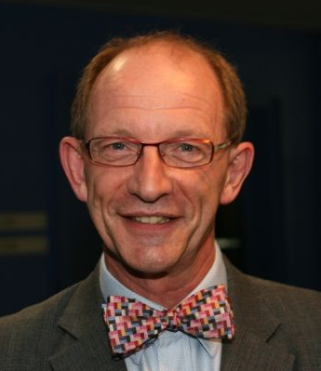
Dr Paul Hutchins AM
Paul is senior staff physician to the child development unit at The Children’s Hospital, Westmead, Sydney. He is senior paediatric consultant to The Children’s Hospital Education Research Institute, which he helped establish. In 2009 Paul was awarded the Medal of the Order of Australia for his contributions to the interdisciplinary care of complex developmental disorders for children and families.
For booking enquiries, or to request a full programme, please contact:
TSA@chadsgrove.worcs.sch.uk
Chadsgrove Teaching School, Meadow Road, Bromsgrove, B61 0JL
Telephone: 01527 871511

