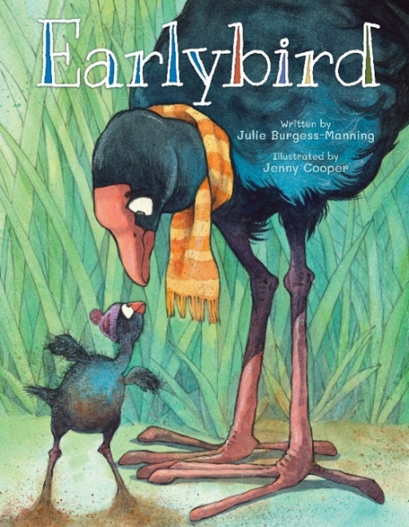
Earlybird

the story of a bird who hatched too early

Written by Julie Burgess-Manning/ Illustrated by Jenny Cooper

Published by Kotuku Press, New Zealand

Earlybird, an illustrated children’s book that tells the moving story of Peri Pukeko, a baby bird who hatched too early and his journey as he gets ready to go home and learns to fly.

The pukeko bird gives the book universal appeal, as the bird commonly known as a ‘swamp hen’ is located throughout the Pacific, with other sub-species in many countries in Europe and Asia.

‘As a children’s story about premature birth, it is unique internationally. Parents of premature babies frequently told me that they did not have a good, or a special story to share with their growing children about their early birth. So, we decided to create a beautiful picture book that would help parents support children born as ‘earlybirds’ to make sense of their early experience,’ says Champion Centre Founder and book co-editor, Dr. Patricia Champion, MBE.

‘All the joys and worries of a prematurely born baby are tenderly and openly addressed in this lovely story as Mum, Dad and Pip welcome little Peri into their nest. This book will be a calming and centring resource for families to read with their children following their time in neonatal and long after…’ (Prof. Linda Gilkerson, Erikson Institute, USA).

‘This sensitively written book will be an invaluable resource for families who experience the premature birth of a child. It will enable parents to support the child to make sense of their early experience as well as helping siblings at the time of premature birth.’ (Prof. Lynne Murray, Child Development Specialist, University of Reading, UK).

‘…they all share his journey to eventually be able to fly and this parallels that of a preterm human infant, getting ready for discharge home. A must read for all children, especially those who have a premature brother or sister.’ (Dr Simon Rowley, Neonatal Paediatrician, NZ).

‘Earlybird is a beautifully illustrated and delightfully told story about seeing what is special in something that can be hard at the same time.’ (Dr. Denise Guy, Child Psychiatrist, President of the NZ Affiliate of the World Infant Mental Health Association).
Earlybird is available for purchase:
https://www.championcentre.org.nz/shop

